Bonaire 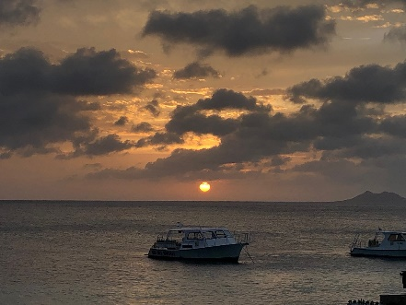

**Coral Restoration and Recreation Diving.**

All **Aquarium Divers For Coral** divers…We have booked Buddy Dive Resort for November 6-13, 2021.  Here are ALL the details:

We are staying at Buddy Dive Resort and have booked their Drive & Dive Package.  It INCLUDES: Your Apartment, Breakfast daily, 8 days of pickup truck rental with tax, FREE WiFi; Welcome drink and Managers Rum Punch Party.  (Rental Car Insurance is Not included); Buddy Dive Resort Hotel Taxes & Fees;

**Reef Renewal Diver Distinctive Special Course**; During 3 training dives and classroom session you will learn ALL the techniques involved in the Reef Restoration process.  You will participate in all the activities that need to be carried out on the nurseries and restoration sites; Also includes 3 dives, course material Reef Renewal Foundation Bonaire Tag and air and OR Nitrox if you are certified to use Nitrox; The duration of this course is 1 1/2 days to 2 days;

We are also booked at Buddy’s Dive Resort 6 days of 1-tank boat dive upgrade with FREE Nitrox!  You need to be Certified to use Nitrox; Along with the Boat Dives we have 6 days unlimited air/shore diving including taxes, FREE Nitrox, tanks, weights & Belts.  The FIRST morning shore orientation dive is required!

**Not**Included is the Marine Park Fee E-Tag of $45.  You will get that on line at[**www.bonairenaturefee.org**](http://www.bonairenaturefee.org/)**;**You will also be required to bring your Dive Certification Card and Nitrox Card (if you are planning to dive Nitrox)

**MORE GOOD INCLUSIONS**:  Buddy Dive Resort - DEMA Special: 50% food credit at the on site polar restaurant-Max of $75 per person per week; and FREE 3, 1 tank boat dives per diver with our 6 boat dive purchase…We do need a minimum of 8 divers to get this DEMA Special.

Transfers are included to and from the Airport.

**ALL OF THE ABOVE INCLUSIONS ARE PRICED AS FOLLOWS:**

3 Bedroom Apartment with 6 people sharing is $1275 per diver and $670 per non diver Price is subject to change per person if the number of people in the apartment is less than 6.

2 Bedroom Apartment with 4 people sharing is $1415 per diver and $810 per non diver. Price is subject to change per person if the number of people in the apartment is less than 4.

**SO WHO’S IN???** We need a $500 Deposit to reserve your spot!  Remember we are only accommodating 16 people…DON'T WAIT.

**CALL** Sydney Fisch TODAY to **RESERVE YOUR SPOT!!!**

All deposits are non-refundable unless we can sell your spot…DON’T wait another minute….Call Sydney at 908-295-4649 TODAY!

All Major Credit Cards Will Be Accepted

*Sydney Fisch*

**Travel Coordinator**

**Scuba Travel & More**